**Araiz, Oscar (b. 2 December, 1940, Punta Alta, Province of Buenos Aires, Argentina – )**

**Summary**

Oscar Araiz is a central figure in the dance world in Argentina and internationally. Maintaining equal prominence in the modern and classical dance communities throughout the course of his career, Araiz’s prolific artistic production includes both original works and signature re-imaginations of repertoire pieces, such as *La Consagración de la primavera* (*The* *Rite of Spring*, 1966) and *Romeo y Julieta* (*Romeo and Juliet*, 1971)*.* Stylistically, his works range from virtuosic neo-classicism to minimalism. The influences that inflect his works are also broad and reflect the confluence of modernist styles circulating through Argentina in the mid-twentieth century, in particular German expressionism and US modern dance. He has served as artistic director of the most significant dance companies in Argentina, including the La Plata Argentine Theatre Ballet, the San Martín Municipal Theatre Contemporary Ballet, and the Colon Theatre Ballet. Internationally, he served as artistic director of the Geneva Grand Theatre Ballet and has worked with companies including the Royal Winnipeg Ballet, the Joffrey Ballet, and the Paris Opéra. Araiz has received multiple honours including the Konex Platinum Award (1989), the María Ruanova Prize (1990), and the Career Achievement Award from the Argentine National Arts Fund (2006).

**Training**

Araiz’s early training in modern and classical ballet techniques began in Bahía Blanca with Élide Locardi. Relocating to Buenos Aires in the late 1950s, Araiz studied with German Renate Schottelius, an influential figure in Argentine modern dance. He also trained classically with Pedro Martínez, María Ruanova, and Tamara Grigorieva, a former dancer with the Ballets Russes through whom he had contact with the influential works of Michel Fokine and Léonide Massine. Training in improvisation with Mary Wigman’s former dancer Dore Hoyer marked another critical moment in his artistic formation. In the late 1960s, Araiz performed with Chilean choreographer Ana Itelman, known for her innovations in the genre of dance theatre in Argentina. Araiz’s training corresponded to the mid-twentiethcentury push toward consolidation and professionalization in modern dance.

**Major Contributions to the Field and to Modernism**

One of Araiz’s first artistic projects was the Today Ballet, co-directed with Susana Zimmermann and Ana Labat during the1960s. An early success was *The Rite of Spring*, premiering in 1966 to critical acclaim. A work revisited throughout his career and the product of a long held interest in Igor Stravinsky’s score, it weaves linear and circular motifs with floor work, weighted and pelvic driven movement, and inverted lines.

In 1968, Araiz was appointed director of the newly created San Martín Municipal Theatre Ballet, the first in-residence, state-supported modern and contemporary company in Argentina. During his brief tenure as artistic director (the company was disbanded by the theatre in 1971) Araiz choreographed his pivotal work *Symphonía* (*Symphony*, 1968)*.* Influenced by visits of the Merce Cunningham and Alwin Nikolais companies to Buenos Aires, the work emphasizes visual components (projection, costuming) juxtaposed with contrasting sound and movement.

In the face of an increasingly repressive political climate in Argentina during the 1970s, Araiz’s career rapidly developed internationally with residencies in Brazil, Canada, France, Germany, the Netherlands, and the US. Araiz returned to Buenos Aires in 1978 when offered artistic directorship of the Colon Theatre Ballet, the most prestigious ballet company in Argentina. Troubled by the military dictatorship from 1976 until 1983, which was a period synonymous with the forced disappearance of an estimated 30,000 citizens, Araiz departed to become the artistic director of the Geneva Grand Theatre Ballet in Switzerland (1980-1988). One of his best known works to emerge form this era is *Tango* (1981), a piece that traces the history of the Argentine tango through a neoclassical movement vocabulary. During this time, Araiz returned to Buenos Aires to present *Fénix* (*Phoenix*, 1984), a piece whose non-normative gender performance challenged the social norms of the moment.

After his return to Argentina, Araiz re-assumed directorship of the San Martín Municipal Theatre’s company (re-instated and renamed the San Martín Municipal Theatre Contemporary Ballet in 1977), a position he held from 1990 until 1998. His works *Stelle* (1989) and *Numen* (1991) signalled an aesthetic departure for Araiz in their use of minimalism and quotidian gesture (specifically walking). Inspired by the movement of the stars, the works offered reflective spaces for quiet and calm in the midst of chaotic economic crisis.

Araiz later directed the La Plata Argentine Theatre Ballet (2002-2003) and the Colon Theatre Ballet once again (2005-2006). In 2010, he was appointed director of the San Martín National University program in dance, a position that influences new generations of choreographers and dancers.

**Victoria Fortuna**

**Selected List of Works**

*Ritos* (1963)

*Crucifixión* (1963)

*Orfeo* (1963)

*El unicornio, la gorgona, y la mantícora* (1964)

*Orpheus* (1964)

*Sinfonía India* (1965)

*El Canto de Orfeo* (1965)

*Halo* (1965)

*La Pazzia Senile* (1965)

*La consagración de la primavera* (1966)

*Estancia* (1966)

*Concierto en ébano* (1966)

*Crash* (1967)

*El Mandarín Maravilloso* (1967)

*Symphonía* (1968)

*Beate Suite* (1968)

*Magníficat* (1969)

*Cantábile a dos* (1969)

*Opus 0* (1969)

*Visiones herméticas* (1969)

*Le Renard* (1970)

*Romeo y Julieta* (1971)

*Adagietto* (1971)

*El Retablo de Maese Pedro* (1971)

*Coloquios* (1971)

*La reina del hielo* (1972)

*Araiz on the rock* (1973)

*Troupe* (1973)

*Escenas* (1974)

*Woman* (1974)

*Constellation* (1975)

*Agitor* (1975)

*Cotillón* (1975)

*Canciones* (1975)

*María María* (1976)

*Eternity is now* (1976)

*Dominio público* (1976)

*Resonancias* (1976)

*Sala de espera* (1977)

*Heptagon* (1978)

*Sueño de una noche de verano* (1979)

*Pulcinella* (1980)

*Ultimo tren* (1980)

*Tango* (1981)

*El beso del hada* (1981)

*Ibérica* (1981)

*Rapsodie* (1981)

*La mer* (1982)

*Tempo* (1982)

*Mathis der maler* (1983)

*Sceherazade* (1983)

*Trama* (1983)

*Fénix* (1984)

*La nuit transfigurée* (1984)

*Les 7 pechés capitaux* (1984)

*Le carnaval des animaux* (1984)

*Street Music* (1984)

*Canto jondo* (1985)

*Orphée* (1985)

*Orfeo* (1985)

*El público* (1986)

*Misia* (1987)

*Panteon* (1987)

*Child Alice* (1988)

*Aqeuelarre* (1988)

*L’enfant et les sortileges* (1989)

*Pléyades* (1989)

*Quimera* (1989)

*Stelle* (1989)

*Numen* (1991)

*Noche de ronda* (1991)

*Salmos* (1992)

*Bestiario I* and *II* (1992)

*Los cuatro temperamentos* (1994)

*Boquitas pintadas* (1997)

*Astor* (1997)

*Apolo y sus tías* (2000)

*Rapsodia negra* (2001)

*El amor brujo* (2001)

*Bagatelles* (2002)

*Flúmina* (2003)

*Torito* (2004)

*Sonata 32* (2005)

*Las bodas-El ruiseñor-Petrouska* (2006)

*Bolero* (2006)

*María de Buenos Aires* (2008)

*Bach Cello Suite* (2008)

*Poema del Angulo Recto* (2009)

*Las Troyanas* (2009)

*Las siete palabras* (2009)

*Escrito en el aire* (2009)

*Splendor* (2010)

*Cabalgata* (2010)

*La Viajera* (2010)

**References and Further Reading**

Araiz, O. (2007) ‘Del hacer una danza’, in *Creación coreográfica*, Patricia Dorin (ed.). Buenos Aires: Libros del Rojas, 7-21. (In this text, Araiz explicates his choreographic practices and theories.)

Buffat, S. (1988) *Oscar Araiz: Carnets de danse, Genve 1980-1988*, Geneva: Favre. (This text documents Araiz’s tenure as artistic director of the Geneva Grand Theatre Ballet.)

Falcoff, L. (2008) ‘La danza moderna y contemporánea’, in *Historia General de la Danza en la Argentina*, Beatriz Durante (ed.). Buenos Aires: Fondo Nacional de las Artes, 231-321. (Falcoff provides a historical narrative of the development of modern dance in Buenos Aires from the turn of the twentieth century to the mid 1990s, including a section dedicated to Araiz’s career.)

Moyano, M. I. (2006) *La Danza Moderna Argentina Cuenta Su Historia*, Buenos Aires: Artes del Sur. (A collection of oral histories of central figures in the development of modern dance in Argentina, including Araiz.)

Rovner, E. (ed.) (1985) *Ballet Contemporáneo: 25 Años en el San Martín*. Buenos Aires: Teatro Municipal General San Martín. (Published on the occasion of the Contemporary Ballet’s twenty-fifth anniversary, the volume includes writings by and on Araiz relating to his founding and extended artistic engagement with the company.)

**Videorecording**

Araiz, O. (2003) *The Geneva Grand Theatre Ballet: Tango*. Sandro Briner, dir. New York: View Video. DVD.

**Web**

<http://www.oscararaiz.com.ar> (Araiz’s professional website featuring photographs, biographical material, and a list of works with musical credit.)

Clip from *Tango*: http://www.youtube.com/watch?v=Xf0wf94ASB8

Clip from *Numen*: http://www.youtube.com/watch?v=e2Uzm6PgEYM

**Photographs**

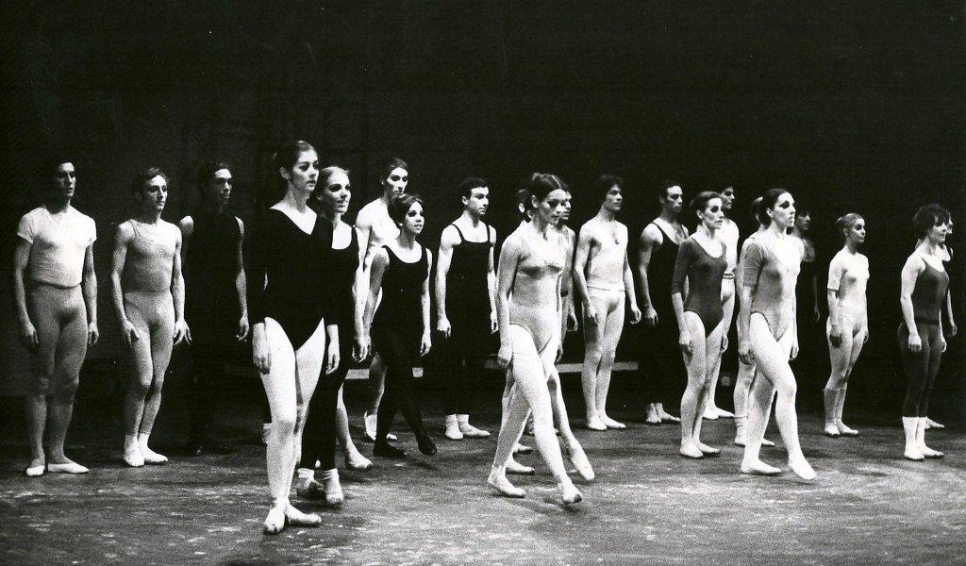

The newly founded San Martín Municipal Theatre Ballet, 1968 (Collection O. Araiz)

Contact: [oaraiz2@gmail.com](mailto:oaraiz2@gmail.com)

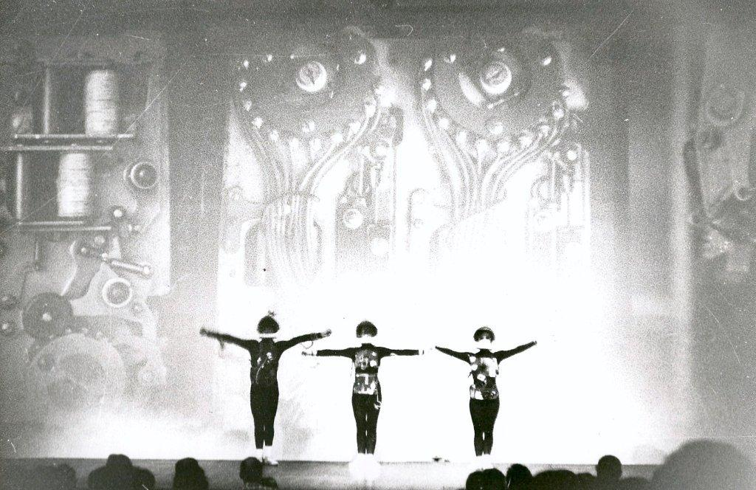

*Crash*, Institute Di Tella, 1967 (Collection O. Araiz)

Contact: [oaraiz2@gmail.com](mailto:oaraiz2@gmail.com)

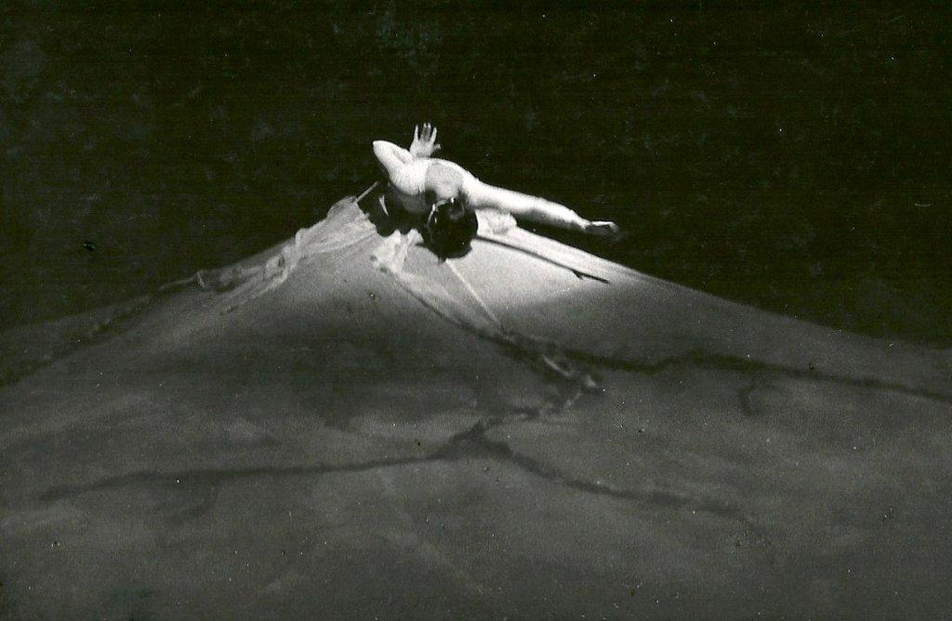

*Consagración de la primavera*, San Martín Municipal Theatre, 1966 (Performer E. Maris, Photographer C. Bourquin, Collection O. Araiz)

Contact: [oaraiz2@gmail.com](mailto:oaraiz2@gmail.com)

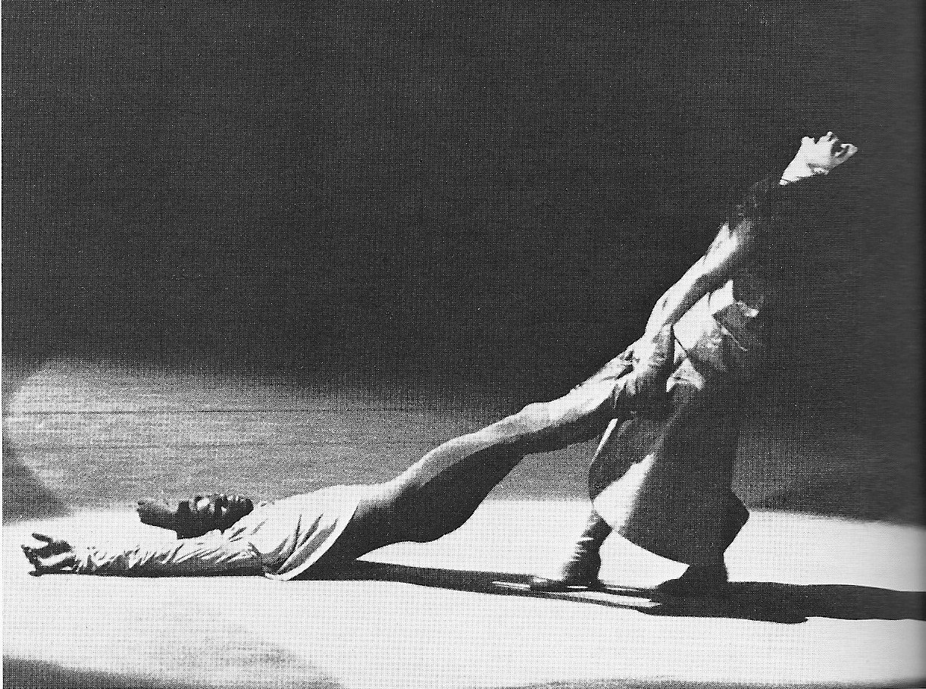

*Romeo y Julieta*, San Martín Municipal Theatre, 1971 (Performers F. Romero and D. Petroni, Collection O. Araiz)

Contact: [oaraiz2@gmail.com](mailto:oaraiz2@gmail.com)

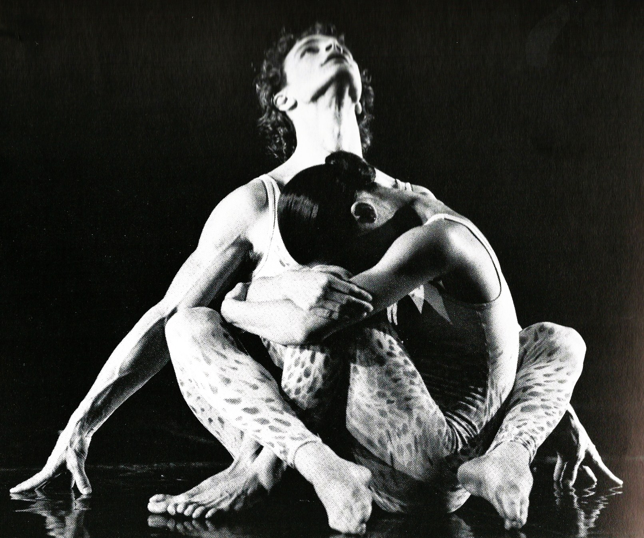

*Adagietto*, 1971 (Performers I. Michaud and C. Andriew, Photographer Buffat, Collection O. Araiz)

Contact: [oaraiz2@gmail.com](mailto:oaraiz2@gmail.com)

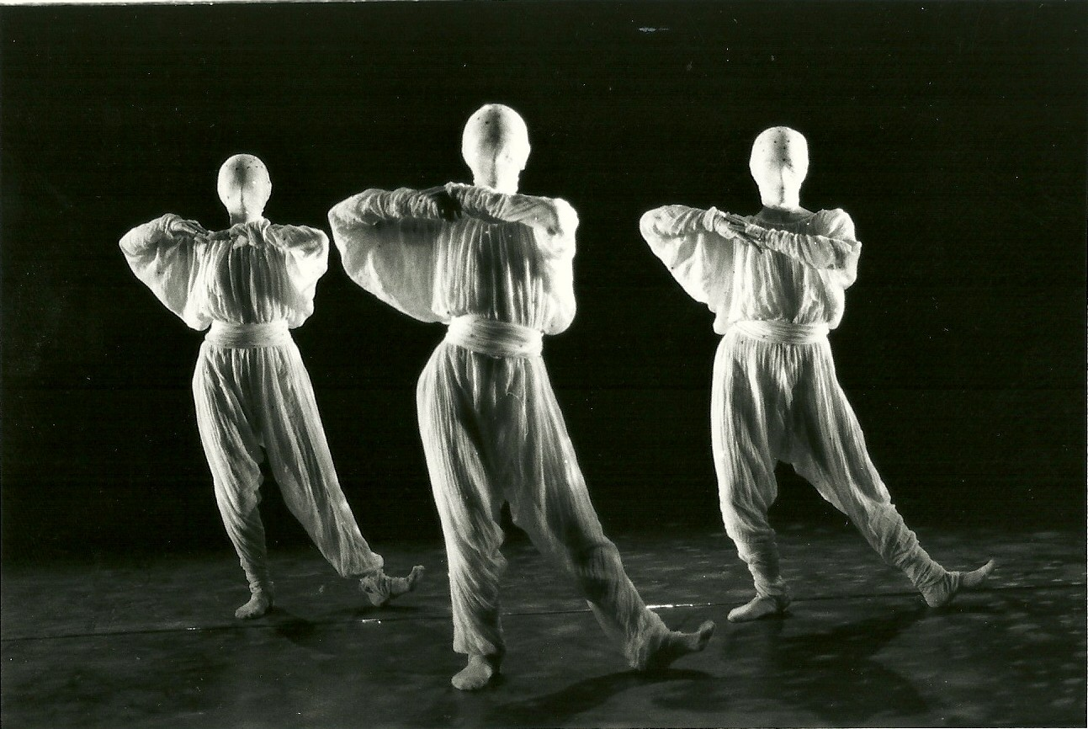

*Stelle*, 1989 (Collection O. Araiz)

Contact: [oaraiz2@gmail.com](mailto:oaraiz2@gmail.com)



*Consagración de la primavera*, Colon Theatre, 2000 (Collection O. Araiz)

Contact: [oaraiz2@gmail.com](mailto:oaraiz2@gmail.com)

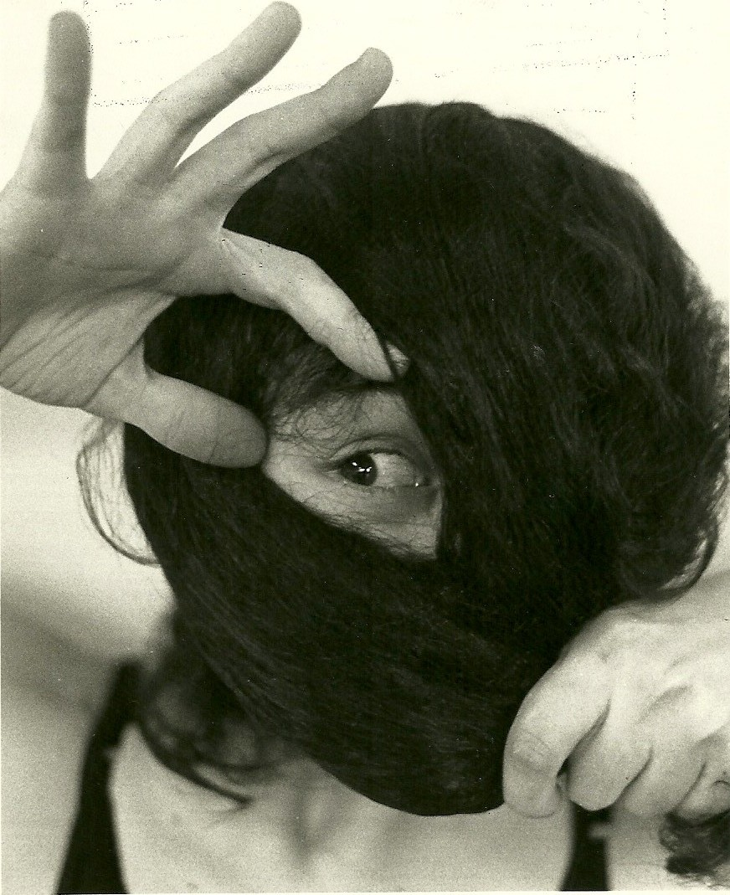

*Numen*, 1991 (Performer Ana Cognini, Collection O. Araiz)

Contact: [oaraiz2@gmail.com](mailto:oaraiz2@gmail.com)